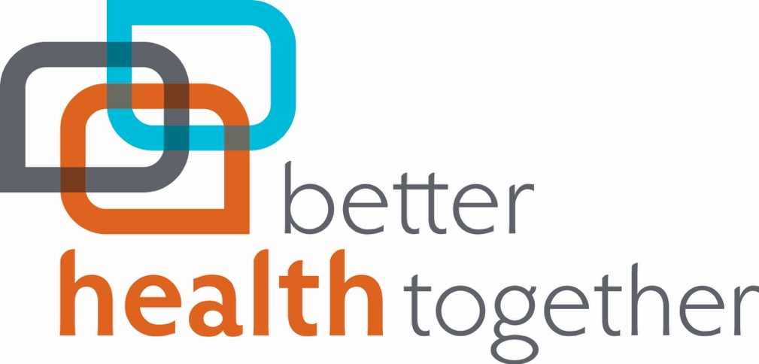

2018 Board of Directors
RECRUITMENT PACKET

Applications due:
April 26, 2018 at NOON to
alison@betterhealthtogether.org

BOARD OF DIRECTORS
Background
Better Health Together (BHT) has intentionally built a multi-tiered governance structure with distributed decision-making, joint ownership, and mutual accountability which drives innovation and creativity, and fosters co-investment that leads to results, not process.

BHT is led by individuals and organizations poised to have the greatest impact on radically improving the health of our region. This structure aims to foster and support regional stakeholder readiness to adopt an amplified “evidence-based, health in all policies” approach. BHT bylaws and Leadership Council charter were purposefully constructed to ensure broad multi-sector and cross-organization collaboration and engagement. The combination of strategic alliances and community engagement strategies ensures that BHT is able to focus on the health status and priorities of the whole community and that no single entity, sector or person dominates the decision-making or activities of the Accountable Community of Health (ACH).

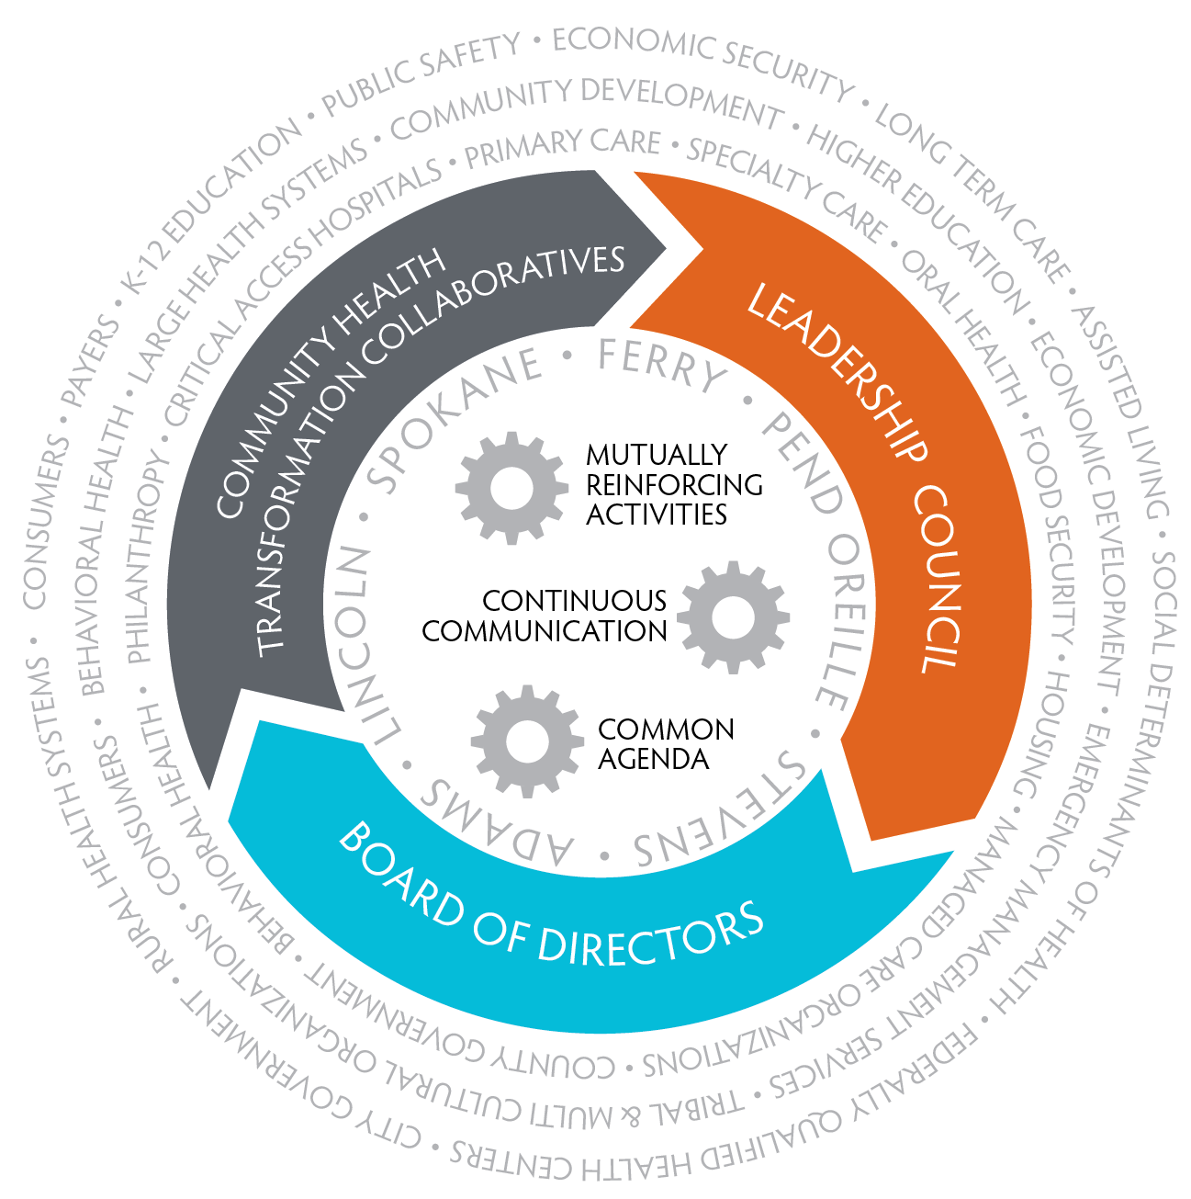
BHT has embraced a dispersed ownership model of decision-making that positions the BHT board as “co-owners and co-investors” in the ACH, not merely a “community based spectator board.” This model has resulted in durable community partnerships that leverage core ACH investments by Health Care Authority (HCA) and other organizations to create measurable, long-term outcomes.

The following figure demonstrates the integrated and inter-dependent governance structure that connects the ACH Leadership Council, Health Champions, and BHT Board. The figure also emphasizes the importance of a common agenda, continuous communications, and mutually reinforcing activities. While the approval of the ACH activities and policies is ultimately the responsibility of the BHT Board of Directors, it is the expectation that the ACH Leadership Council and Health Champions will play a significant role in influencing the development of our region’s health transformation plans.

Position Description
BHT‘s 19-member Board of Directors is a leadership board with the final governance authority for our region’s ACH efforts as well as overall fiduciary and strategic oversight for all aspects of BHT. This multi-sector, highly accountable structure provides the ability to seize on opportunities and demonstrates a commitment to co-investing in activities for our ACH and the Navigator Network of Eastern Washington.

Board members are selected based on the following:
- Senior level executive, with the ability to align individual organizational resources to meet BHT goals
- Respected community leader, with the ability to cultivate, inspire, and influence other leaders in their sector to align resources and efforts
- Visionary yet practical leader that will move our efforts from concept to action
- Ability to balance organizational needs with community best interest

Board Terms of Service & Expectations
- Board members serve three year terms, with a maximum of three terms.
- Annually, Board members will complete a self-assessment on participation and engagement with BHT and will request feedback from the ACH Leadership Council, HCA CCHE Evaluation efforts, and other community stakeholders.
- Every two years the Board conducts an evaluation on board and member effectiveness.

Our expectation of the Board of Directors is to:
- Provide strategic guidance on issues critical to improving health in our region based on their experience, expertise and perspective.
- Approve ACH decisions, seeking feedback from Leadership Council, Health Champions, Technical Councils, and other sector representing entities.
- Provide management, fiduciary and strategic oversight over BHT’s programmatic efforts.
- Serve on the ACH Leadership Council as well as at least one other BHT Board Committee including: Finance, Executive, Governance, and Audit and actively participate in other ACH related community engagement activities.
- Communicate with other members of their sector, community, and/or Native American Health partners to ensure effective information flow and strong engagement on matters related to the ACH.
- Proactively solicit input, seek feedback, and update other organizations within their sector.
- Disclose differences of opinion or disagreements within their sector on decisions to the Board of Directors.
- Disclose any substantive or perceived Conflicts of Interests as it relates to sector effecting decisions and/or the ACH.

BHT will always strive for ethnic, gender, political and age diversity to ensure diverse perspectives are represented on the board. For this round of board recruitment, we are seeking nominations from individuals with the following characteristics:
- Ethnically diverse senior level exec and/or respected community leaders, with the ability to cultivate/influence/inspire other leaders in their sector
- Visionary yet practical leader
- Ability to balance organizational with community best interests
- Provider representation with a focus on Substance Use providers
- Leaders that represent Community Voice especially from under-represented populations on the board

The Board membership will be comprised of the following expertise, knowledge and background as key to the success of the board:
- Health Care
- Health Plan/Managed Care/Payer
- Population Health
- Provider
- Representatives from Tribal Health partners
- Behavioral Health
- Public Health
- Education
- Social Determinants of Health
- Aging & Long-Term Care
- Philanthropy
- Consumer
- Government

BHT relationship with EHF
- EHF expects that the BHT Governance Committee will identify the five EHF appointed board members.
- EHF has requested that at an effort be made to have two board members on the BHT board who also serve on the EHF board to increase collaboration, integration, and strategy alignment.
- BHT bylaws require that one of EHF appointed board members serve on the Executive Committee.
- It has been the practice to have a senior level EHF staff member also serve on the BHT board, this position would be one of the five EHF appointed board members.
- Annually, BHT will submit identified board members for ratification to fulfill bylaws.

Open Board Seat Recruitment Process
March 28, 2018: Board approves timeline and desired characteristics

March 29, 2018: Launch of Board Nomination Process for two open seats announced via:
- Weekly ACH update
- BHT website
- Via all BHT Technical Councils
- BHT Social Media

April 26, 2018 at Noon: Complete Nominations Due (Complete Nomination packets to include Resume, Application, and one letter of support from a BHT Board, ACH Leadership Council, or Technical Council member).

Week of May 3, 2018: Governance Committee reviews applications and selects slate to recommend to Board.

May 30, 2018: BHT Board votes on recommended slate.

June 20,2018: BHT Board member orientation and first board meeting

Board of Directors
Candidate Application

Please attach your current Resume and /or CV and a Letter of Support from a current Better Health Together Board member of ACH Leadership Council member.

Name
First MI Last

Residence
Address
Phone ______________________________E-mail

Business Information
Name
Your title
Address
Phone ______________________________E-mail
Type of business or organization ________________________________________
Primary service(s) and area/population served _______________________________

Please list boards and committees that you serve on, or have served on (business, civic, community, fraternal, political, professional, recreational, religious, social).

Organization Role/Title Dates of Service
_______________________________________________________________________
_______________________________________________________________________
_______________________________________________________________________
_______________________________________________________________________
_______________________________________________________________________

Please describe how Better Health Together would benefit from your involvement.
_______________________________________________________________________
_______________________________________________________________________
_______________________________________________________________________

Please select areas of expertise and experience:
 | Population Health |  | Serving Underserved and Low-Income Populations
 | Social Determinants of Health |  | Serving Communities of Color
 | Health Care System |  | Policy Development & Advocacy
 | Health Plan/Managed Care |  | Strategic Planning
 | Native Health |  | Nonprofit Experience
 | Native Human Service Delivery |  | For Profit Experience
 | Education |  | Program Development & Policy
 | Aging and Long-Term Care |  | Social Enterprise
 | Oral Health |  | Fundraising
 | Substance Use Disorder |  | Communications & Branding
 | Provider |  | Finance, Accounting
 | Public Health |  | Legal
 | Mental Health

Please list any groups, organizations or businesses that you could serve as a liaison to on behalf of Better Health Together.
_______________________________________________________________________
_______________________________________________________________________
_______________________________________________________________________

Please tell us anything else you’d like to share.
_______________________________________________________________________
_______________________________________________________________________
_______________________________________________________________________

Please return Application, Resume and Letter of Support to:
Alison@betterhealthtogether.org by April 26th at Noon

