DBHR COVID-19 call for behavioral health providers
March 24, 2020

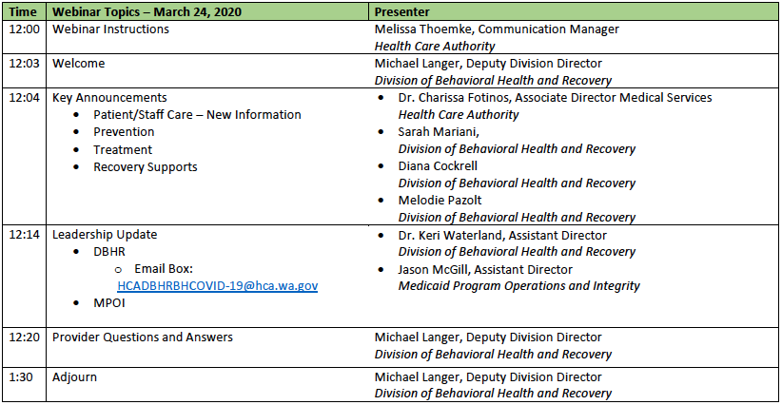

Corrected Email Box: HCADBHRBHCOVID19@hca.wa.gov (no hyphen)

Questions coming from Prevention – Sarah Mariani
- Do need to stay w/in parameter of grant goals, though flexible in implementation
- Track/record adjustments

Children’s Team & Adult SUD team – Diana Cockrell
- Contract deliverables, stay in contact with contract manager, case by case changes
- CYF side – guidance for family outreach & family peers forthcoming

Recovery supports – Melodie Pazolt
- CPC trainings – working on getting those going to meet workforce needs
- Stay in contact with contract managers on deliverables (recovery cafes, cub houses, etc)

Leadership update – Dr. Keri Waterland, Jason McGill
- Use email box for questions HCADBHRBHCOVID-19@hca.wa.gov, include Prevention/Treatment/Recovery in subject line so it can be properly directed
- Working on FAQ from questions received
- Working with MCOs on solutions to speed up, advance payments for providers
  - Teresa Claycamp (HCA) to share more info
  - No detailed instructions at this time from fed on what flexibility they will provide

Teresa Claycamp – updates on billing
- BH providers contracting with MCOs under IMC – use same inbox with billing issues/questions HCAMCprograms@hca.wa.gov
- Email with concerns that you won’t be able to sustain self over next 2-4 weeks
  - Subject: URGENT Financial Need, Body: details of what you’re struggling with

Q&A
- Q - Reimbursement for audio-only services?
  - Gail Krieger – we WILL be reimbursing for telephone calls, as well as online exchange thru a patient portal, also if you use a telephone for skype or facetime. Receive info from CMS that allowed to broaden what we can reimburse for. Current telemed policy will stay in place, but can reimburse for additional forms of telehealth.
    - FAQ available – Melissa Thoemke will send out draft by end of day by email
- Q – had to cancel counseling groups, haven’t been able to get virtual option going yet, can we recover any funding for groups we had to cancel?
  - Email box above about urgent financial need
  - Also working with MCOs on delayed payments to help with cash flow
- Q – LMHC who lives in Oregon but with WA license (no OR license), provide telehealth from home for clients she would normally see in WA
  - She can provide since she is licensed in WA state
- Q – number of services drastically decreased, working on getting teleservices up and working, and take time to get patients back into service. Is it that funds might be available now, but might have to reconcile later
  - Hoping that is not the case, trying to find sustainable options
  - In the very short term, we may have limited options that require some reconciliation later
  - Follow-up – so we can’t get approval to do capitated rates?
    - Some providers already on PMPM, in those circumstances, still require annual/semiannual reconciliation that services have occurred
    - Looking at that option, but still need additional flexibility from feds
- Q - How do we access Zoom options for telemeetings?
  - State has limited number of licenses available for BH providers: https://www.hca.wa.gov/billers-providers-partners/prior-authorization-claims-and-billing/request-zoom-license-connect
  - Getting licenses out as applications come in
- Q – Confused over when to use modifier CR and GT (DT?) when billing telehealth
  - GT modifier used when using true telemed – audio/visual real time
  - CR modifier when using phone or other things not included in telemed definition
  - Want to keep track of differences of how services are being provided
  - If can’t get EHR modified, then use the most appropriate code you can and document how it was provided, if using modifier is not an option – not sure what issues will encounter, so want to provide guidance but flexibility
- Q – Suspended urinalysis testing, including at time of assessment, so don’t know what substance on
  - As part of regular care (and not court ordered) then best left for a different time
  - If it is court ordered, talk with that particular court for guidance & allowance
- Q – What do we enter for location if working from home?
  - Place of service code is related to where client is. Use 02 for place of service. For telephone with CR modifier, put in where client is using normal codes.
- Q – could we push for during this time we do temp adjustments to contracts to request higher pay rates?
  - Exploring those options, as well as increased rates for telehealth
- Q – Universal language services charges $1.60 a minute for translation over the phone. Medicaid will pay up to $40 for reimbursement. Anything beyond that we can get paid?
  - Working on more comprehensive over the phone interpreter solution, forthcoming
- Q – MAT provider in FQHC setting. Hearing we can only bill for 1 phone visit per week
  - Not true. Not doing any limits.
- Q – curious how consent is obtained in televisits. Verbal consent with documentation?
  - That is what we are advising. Working on training to help with framework of those conversations
  - Until that training, document information shared with client and client’s verbal consent, date & time
  - When back to normal, have client sign form in writing, including that they provided verbal consent on that date as a CYA
- Q – SUD and adolescent, are zoom licenses 42cfr compliant?
  - Zoom is HIPPA compliant
  - SAMHSA has given permissive to provide services during this crisis – document available on website
  - Unless taping and plan to share, then wouldn’t be issue
- Q – lived in ID, works WA, licensed in both states. Can provide telehealth?
  - As long as you are licensed in WA, no issue
- Q – Tonya Stern, question from OTP provider, can they do telehealth for OTP
  - Guidance on website related to OTP – clinical policy & billing
- Q – can we adapt our parenting services to provide remotely via Zoom?
  - Yes, allowing flexibility to deliver parenting classes. Putting together some implementation webinars about how to do those, adjustments to make
  - Work with contract manager for any adjustments need to make
- Q – Official guidance on when to hold/not hold groups in out-person setting
  - To be consistent with directive, do everything possible remotely
  - If concern that client is too unstable and needs an in-person visit, that would be a different consideration
- Q – any guidance on PPE that is being requested? E.g. effectiveness, alternatives
  - Interim draft from Labor & Industries that was put out
  - Will get up on COVID website
- Q – residential providers struggling with what to do when we get a resident who tests positive? Discharge, quarantine, quarantine staff, guidance, etc.
  - Guidance for LTC facilities currently – how to isolate, how to clean room, what type of contact is okay. Discharge piece will rely more on if there is a safe place to discharge too, their stability, if it’s clinically appropriate
    - Will post that
  - Follow-up Q: Which staff to be quarantined? What other residents who might have had contact should be quarantined? Self-administration of meds for quarantined clients? Haven’t seen that guidance
    - Need to look into getting/finding guidance
    - Send into mailbox
- Q - Look for info about billing for services that are being provided over phone, but usually required to be provided face to face
  - Coded as normal service (SERI, Mental Health Guide, etc.), then bill the CR modifier
- Q – can you advise on taking verbal auth for release of information? Assumes electronic signature isn’t an option
  - Depends on circumstances. Need more detail to answer.
- Q – Looking for guidance for serving children & families in crisis. Trying to observe CDC guidance & governor’s mandates. But families are in crisis but only able to talk to on phone under guidance. Looking for additional guidance.
  - Depends on circumstances. Need more detail to answer.
- Q – so many questions around billing and modifiers. Can we get a guidance doc?
  - It is in the FAQ that Melissa will send out after the call
- Q – have clients struggling to stay clean & looking for places for detox or treatment. Any places currently accepting clients?
  - Yes, there are programs that are taking patients. Probably have to make phone calls in local area.
  - Have list of who has suspended services, but not list of who is open – changing constantly. Probably best to just call.
- Q – movement on approval for DCRs to do video eval?
  - Are working on this, asking for a little more patience. David Reed is lead, working with attorneys general
- Q – concerning FCS clients for employment services, will virtual face-to-face be billable the same as face-to-face contact?
  - Need to get back to confirm
- Q – status for approval on Zoom licenses, how long have to wait to get that?
  - They are processing, don’t know turnaround time. Will ask IT folks for update.
- Q – if we have a phone call with client, can we get verbal consent then sign physical form later?
  - Yes, that is the recommendation

Still had a queue of questions – send those questions to new mailbox if didn’t get to them
- Will have call again next Tuesday

