DBHR COVID-19 call for behavioral health providers
March 31, 2020

Updates from HCA – Michael Langer
- Provider requests for Zoom licenses, receive notification within 4 business days of submitting request
  - Must click on link in email to register your license
  - If have questions, email HCADBHRBHCOVID19@hca.wa.gov
- If you need to update your contract because of COVID
  - If changes do not involve budget increase, work directly with contract manager over email
- Prevention
  - If staff diverted to respond to COVID-19, if work changes or is diverted to different settings/sectors (e.g. LHDs), that other work cannot be billed to DBHR
  - Drug Free Communities Grant Funding application extended
- Treatment
  - BH Treatment Provider Funding Support – Alice Lind & Jason McGill
    - Will be putting out in writing on COVID webpage - Integrated Managed Care BH Provider Support (IMC BH COVID) - expect to post later today after this call
    - Convos with MCOs about identifying providers who need priority assistance – priority on FFS or per diem contracts & providers who are sole source of BH in a community
    - MCO will contact providers to ID appropriate solutions – advance payments based on historic volume (which may include reconciliation or repayment, no sooner than 6 months out); capitated contracts; other approached may happen on case-by-case basis – release advanced enhancement funds, budget based contracts
      - MCOs committed to have plan with priority providers by April 8
    - Continuing to take in requests, see email boxes below
    - Also talked about payment/claims in arrears to get paid promptly

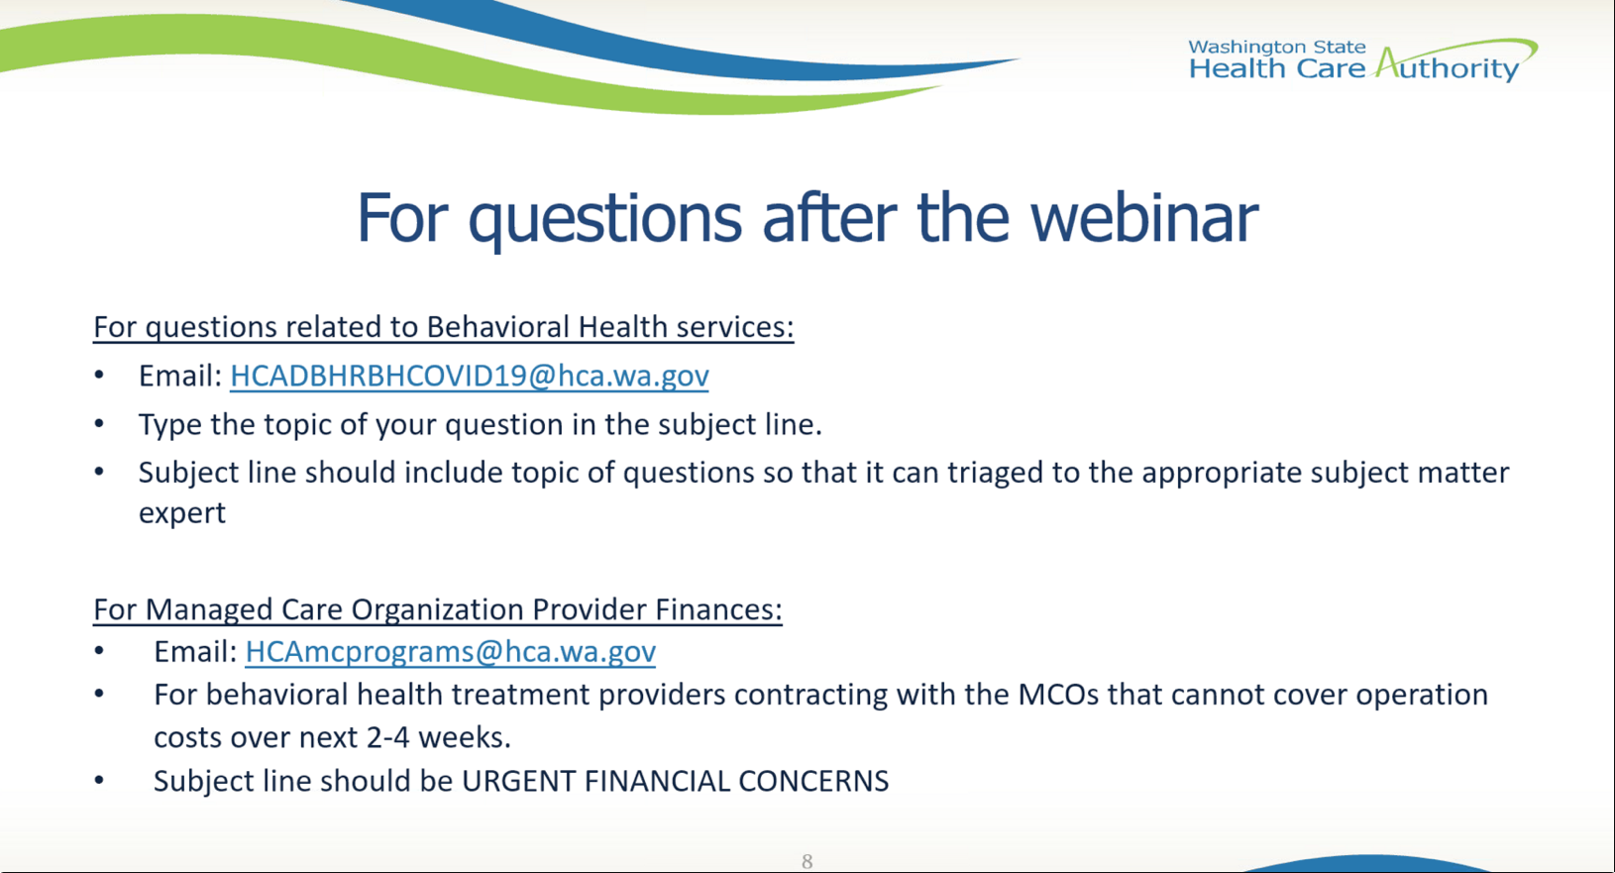

  - Telehealth BH training & TA Plan
    - Working on
    - Contacts – Melody McKee melmckee@uw.edu, Ethan Norris enorris@healthmanagement.com
  - List of Treatment Providers Reduction & Closures of Facilities
    - Updated daily if there are changes
    - https://www.hca.wa.gov/assets/program/covid-19-provider-program-impact-list-20200330.pdf
    - Email HCADBHRBHCOVID19@hca.wa.gov to report changes
- Recovery (RSS)
  - Increased flexibility to provide RSS services telephone
  - Increased flexibility on housing subsidies
  - Pursuing virtual platforms for CPC training
  - Pursuing support fund for individuals and retention payments for providers thru 1115

Patient & Staff Care – Dr. Charissa Fotinos
- Shared info with DBHR that will be posted on COVID page
- Hearing & working on concerns about PPE

Q&A
- Q - Owed 3 months back from MCOs, can survive if get those funds
  - MCOs working on hang-ups and clearinghouse challenges
  - email HCAmcprograms@hca.wa.gov, note which MCO(s)
- Q – plea to get PPEs for our DCRs, limiting type of situations DCRs can interact with folks, are dispatched to EDs, homes, jails, etc.
- Q – intakes over the phone, what is the billing code for that? (Morgan at Catholic Charities)
  - Same procedure code, use the CR modifier and place of service 12 (client is at home)
  - If you can’t use those because of your EHR, use the same codes you would always use
- Q – for providers in capitated contracts receiving PMPM, seeing encounters drop. Will we see adjustments in the future, or be asked to repay/reconcile down the road? Can we feel confidence in keeping our staff employed?
  - Realize there will be challenges about rate setting & financing. For current capitated, need to look at your specific contract with the MCO. Work with MCO contract contact. If you do have capitated arrangement, you are better covered for the moment than FFS.
  - DBHR will also take back to MCOs to discuss
  - At this time, HCA is not calculating any adjustments to rates or funding we send out to MCOs or BHOs
- Q – subsidized housing at hotels, more info on that?
  - Thru housing and recovery for peer services, have some funds for folks at risk of entering inpatient, want to be flexible for folks who have emergency needs. If you have a HARPS teams in your region, work through them
- Q – waiving normal BH licensing that would require in-person/F2F assessments. What type of assessments would that include? Residential?
  - Waiver from DOH for exception for F2F is on the COVID website, calls out specific WACs to which it has waived the F2F requirement.
  - OTP providers still have to do physical exams, bc that’s in CFR
  - Have to get back to you on residential as part of follow-up
- Q – concerned about DBHR provider contracts, under contract to provide problem & pathological gambling services. Continuation of services for clients after June 2020?
  - Get a hold of your contract manager about contract renewals
  - These are 2 year contracts, so expect to continue through June 2021 with no change
- Q – experiencing case rate mgmts. at increased rates to help individuals log into groups & sessions. Many under 10 minute minimum in SERI. Another code or can minimum be waived? Under the limit for each person you’re helping.
  - You can use that code for the instruction time. But need more information about how it’s being conducted about how to specifically bill.
  - Clarification – for both groups and individual counseling, helping folks get logged on. Case workers doing something like 5 minutes, 10x a day.
  - Gail – will work with others and get something posted about that.
- Q – DOH website says there is a waiver on F2F restrictions, but billers hearing from MCOs that there are still restrictions
  - MCOs have been told to waive the restrictions for F2F, received FAQ & said they will respond to provisions
  - Email the HCADBHRBHCOVID19@hca.wa.gov if folks continue to hear this
- Q – clarify correct place of service when both clinician & client are at home, and telephone only
  - Place of service code is always where the client is – 12
- Q – Advice to get verbal consent, then sign when back in person. But we have a % of clients who do SUD assessments and don’t come back. Recommendations?
  - Info sent to colleagues – UW is working on training & best practices for issues like this
  - Document verbal consent, provider dates & signs
- Q – heard from MCOs may not able to pay cost reimbursement, we have an extreme amount of no-shows. Already had to layoff 25% of staff and go to 4 day week.
  - Need additional guidance from CMS, going to be challenging in short term. Will continue to report back on these calls
  - Teresa Claycamp – make sure provider has emailed inbox with urgent financial concerns HCAmcprograms@hca.wa.gov
- Q - will Zoom invitation come from Zoom stating that HCA person requested to add to Zoom account
  - Email will come from Huong Nguyen-Nabors
- Q – Parenting Prevention (Guiding Good Choices) programs have had to cancel groups. Can we use funds for things like purchasing technology?
  - We are making adjustments to contracts – host remotely, etc.
  - Contact your contract manager to document that, and amendments will be made after COVID period
- Q – What do we do when MCOs say they are not set up to pay us cost reimbursement?
  - That is again an individual contract question. MCOs have a variety of payment mechanisms available to them. Free to talk to MCOs about adjusting payment mechanism.
- Q – if agencies have to temporarily close, will MCOs terminate contracts?
  - Look to contract terms. We need providers in network, and will have need after COVID. Will not allow MCOs to operate in state of WA without a solid appropriate network.
- Q – For folks graduating in next 4-8 weeks with Masters, how long to get provisional info approved from time state receives their information?
  - DOH question – need to take it to them, will follow up
  - On HCA side, provider enrollment folks worked overtime to push thru applications. DOH is also working on improving push thru
- Q – mass movement to telehealth has disadvantaged a huge number of folks who receive services
  - MCOs & plans providing phones to clients, LifeLine
  - Under 1115 amendment we’re seeking, working for FCS ability to get phones out to people
- Q – will HCA provide a fair hearing approach when provider feels they haven’t been kept whole bc of reconciliation?
  - Will take that idea back to this issue. Expect to share more info in days/weeks to come
- Q – how will providers be notified on UW guidance release?
  - Will be shared with this group
  - Also best practices shared on Telehealth Webinar on April 3 (REGISTER HERE)
- Q – Molina is saying place of service should be place where service would have occurred regularly. All other MCOs using where the client is.
  - The place of service is where the client is, not where they would be
- Q – requesting PPE
  - Connecting to local health jurisdiction is best place to start that request process
- Q – our FCS employment division has laid off almost all specialists
  - Unfortunate since a lot of work can be done over the phone
  - Send to HCADBHRBHCOVID19@hca.wa.gov email so can document
- Q – is state testing for SUDP licensing during this time, or suspended until after this is over?
  - Have to get back on that question
- Q – any news on increases in the state budget?
  - Nothing new to report, expect governor to take action on budget in the next few days. We will wait for that.
- Q – can we bill FCS through telehealth or telephone? How to bill?
  - Yes you can bill. Code it the same way. Work with MCOs on questions, or email HCADBHRBHCOVID19@hca.wa.gov

Additional Resources – see next page
