HIT Operations Call
March 24, 2020

Draft Agenda:
Topic | Presenters | Time
Commons IT Network | Rob Arnold, The Commons  Adam Davis, Puget Sound Regional Fire Authority | 15 min.
Telehealth/  Telebehavioral Health  Topics include:  - What is it?  - How can it be used, including for mental health and substance use disorder services?  - Provider experience in telehealth/ telebehavioral health implementation  - How are telehealth services paid by Medicare and Medicaid?  - Upcoming virtual NRTRC conference | NW Regional Telehealth Resource Center (NRTRC) : Deb LaMarche Program Director & PI, Northwest  Cara Towle, RN, MSN: Associate Director, Psychiatry Consultation & Telepsychiatry, University of Washington  David D. Luxton, PhD., M.S.: Associate Professor, Department of Psychiatry and Behavioral Sciences, University of Washington School of Medicine, Seattle (author of WA State Telehealth Toolkit)  Washington BH Providers: Telehealth Implementation Experience (presenters TBD) | 1 hr. 15 min.

Commons IT Network – care coordination platform
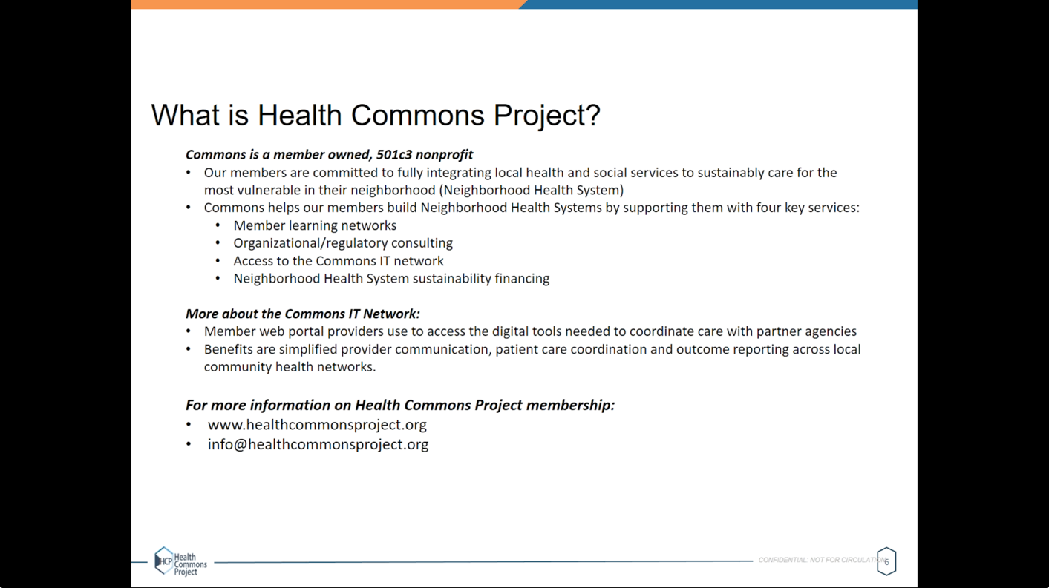
Puget Sounds FD – test site for Health Commons Project
Q&A
- Is this coordinated with DOH testing registration? – specimens go to UW lab, still understanding process
- Barriers/challenges –complexity of service integration, regulatory/IT levels

Telehealth/Tele-behavioral Health agenda
- NW Regional Telehealth Resource Center – Deb LaMarche
  - CMS relaxed rules for Medicare telehealth re:
    - patient location, including urban areas and in home
    - requirement of prior established relationship
    - allow providers to reduce or waive beneficiary cost sharing like co-pays
    - permits beneficiaries to use telehealth to receive services
  - allowed to use any non-public facing remote communication product
  - Slides to be shared

UW Psychiatry Consultation & Telepsychiatry
- Free psych case consultation services - TAP (Telepsych Access Program)
- Details on UW “Consultation & Telepsychiatry” webpage
- UW PACC-ECHO for providers wanting to improve MH/additction care for patients, 12-1:30 Thursdays
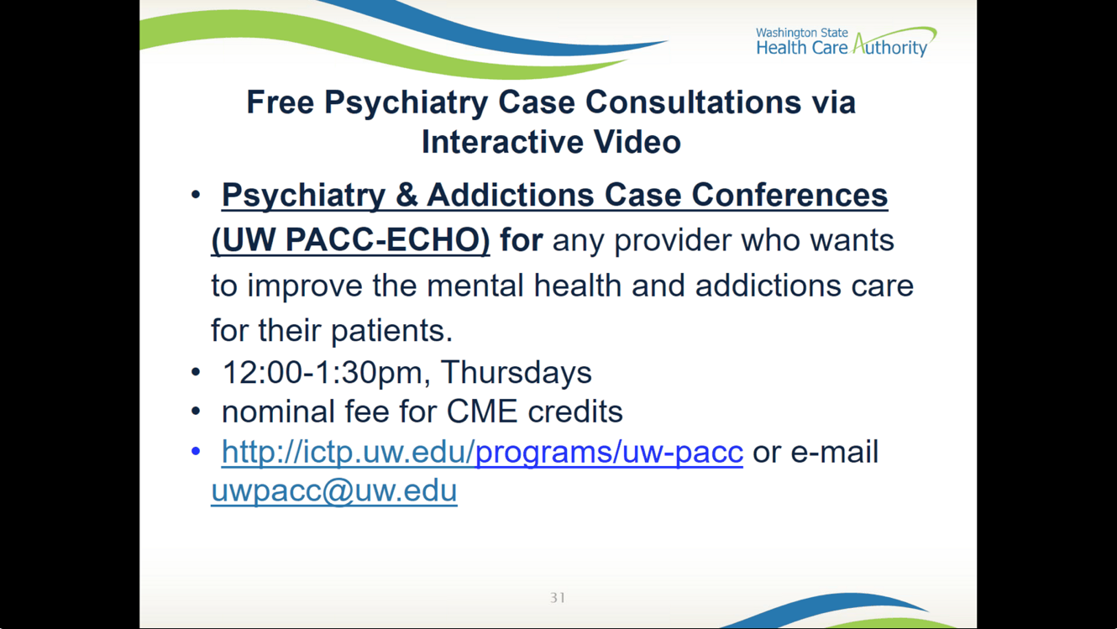

HCA, Gail Kreiger
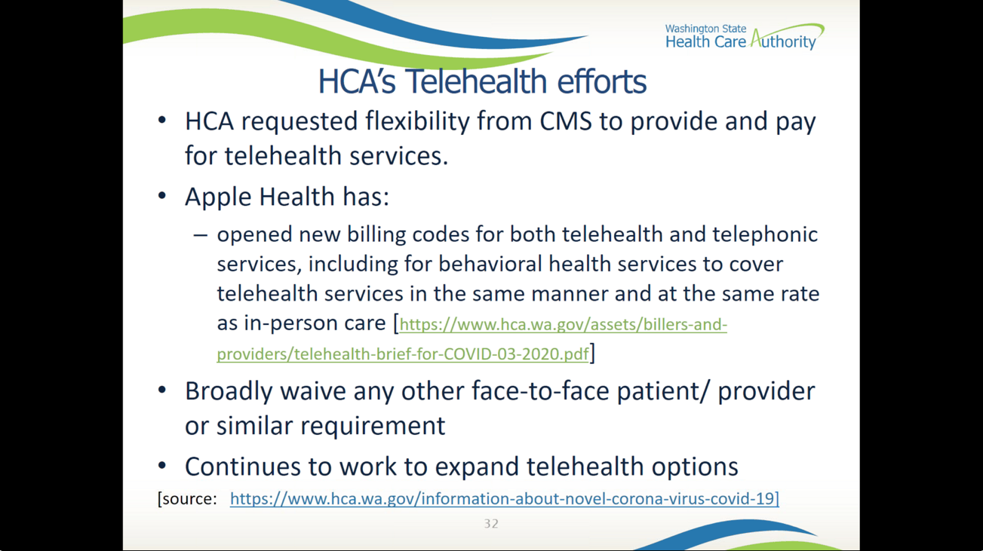
  - Paid at same rate as in-person care
- WA Telephone Assistance Lifeline Program: http://www.lifelineprogram.org/lifeline-washington/
- HCA Zoom licenses
  - See website: https://www.hca.wa.gov/billers-providers-partners/prior-authorization-claims-and-billing/request-zoom-license-connect
  - Eligible providers: meaningful number of Medicaid clients; do not have other HIPAA or 42 CFR compliant video capabilities; smaller & rural practices with less infrastructure; serving children, adolescents, pregnant/parenting, tribal members; OTPs; prescribing to people diagnosed with significant MI/SUD; community MH centers
- SAMHSA Guidance on 42CFR
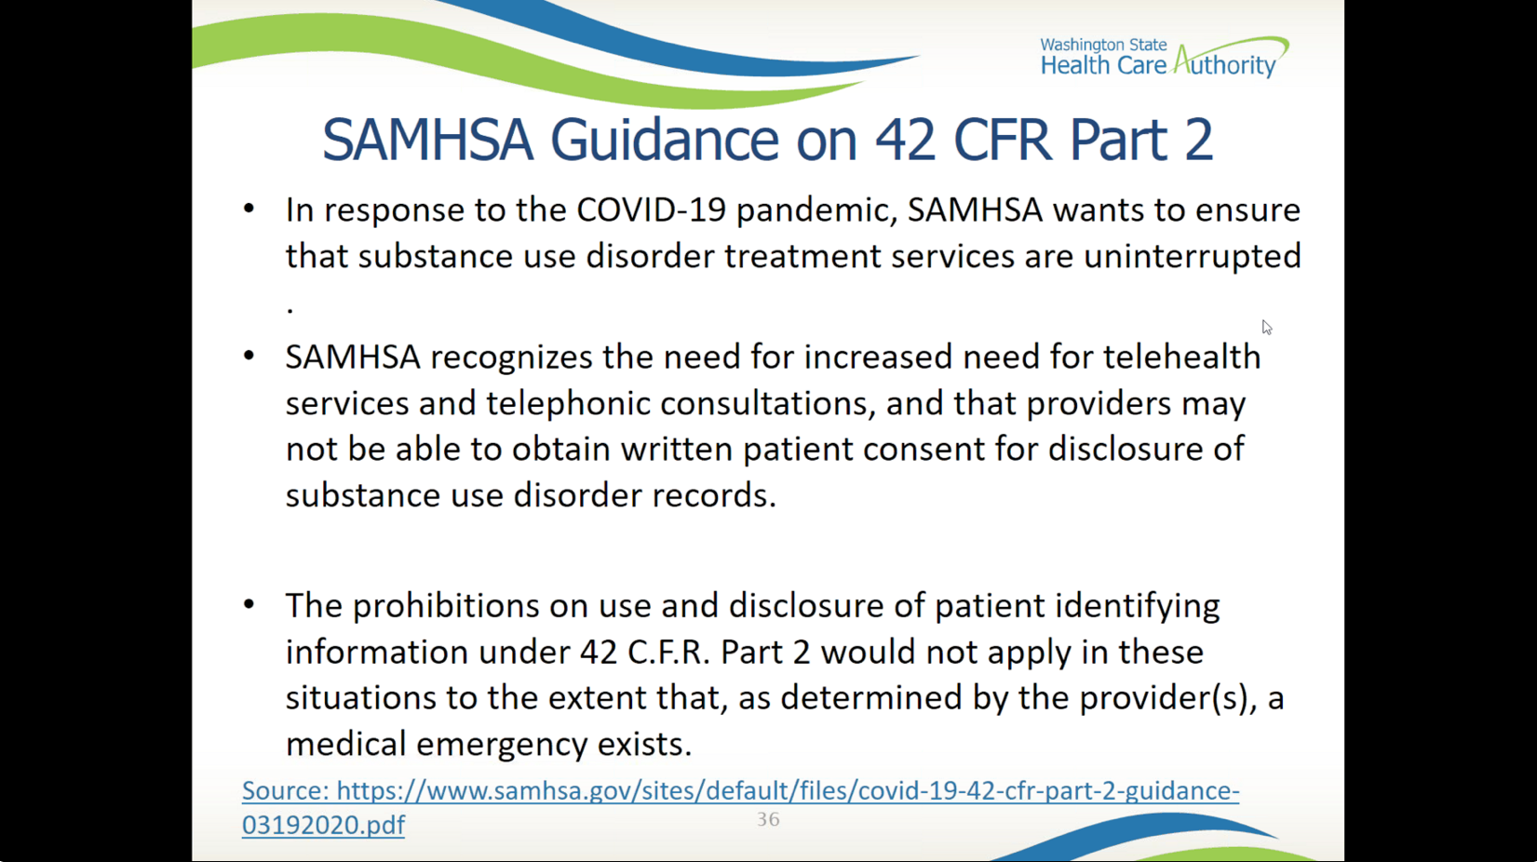

Q&A #1
- Do relaxed rules include SUD services?
  - Yes, SAMHSA guidance includes SUD services in using telehealth mechanisms
- FaceTime for SUD?
  - Yes, with informed consent. Can be provided verbally with date & time, then signed physically later
  - DBHR staff working to provide training around informed consent, electronic signature, & other guidance
- Can FQHCs bill MediCare for telehealth services?
  - Deb LeMarche – FQs and rural health clinics at this point cannot bill as the distance site provider. Can bill if they are the originating site where the patient is. This may change in the next few days.
  - More details on HCA COVID page under Clinical Policy & BH Policy links
- Many additional questions – ran out of time

WA BH Providers Telehealth Implementation experience
- Ideal Balance (part of Ideal Option) - SUD telehealth
  - Suggestions:
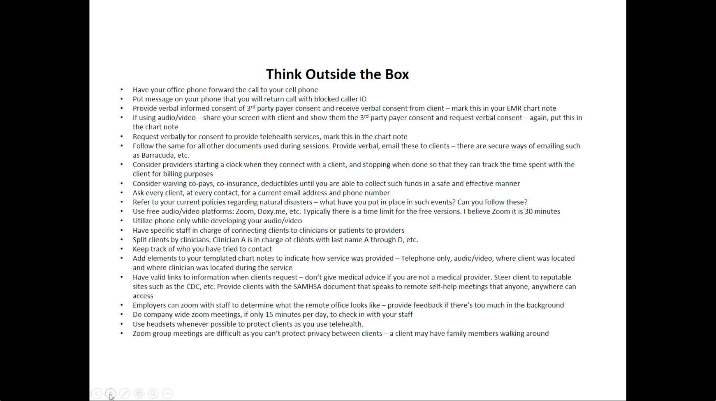

WA State Telehealth Toolkit (WA State Guidebook) – Dave Luxton
- Includes checklist for implementing new telehealth systems, leans BH
- Available on DSHS website
- Other practice guidline resources
  - American Telemedicine Association
  - American Psychological Association
- Links in slides (forthcoming)

Q&A #2
- Many about billing codes, Gail no longer on call
  - Will follow-up in writing
- Q - Using telehealth to conduct outpatient groups?
  - Ideal Balance – we don’t do group sessions, just individuals & families
  - Concerns about confidentiality
  - Deb LeMarche – have hosted support groups for moms w/ perinatal depression, grief groups
    - 6-8 patients, 1-2 practicioners/facilitators
    - Seems to have worked well for those type of groups
- Q – expanded billing to include LMHC, LMFP
  - Have not so far changed any of the provider types that Medicare will reimburse

Slides & recording of webinar will be posted, email to registrants
- Slides include additional COVID resources

